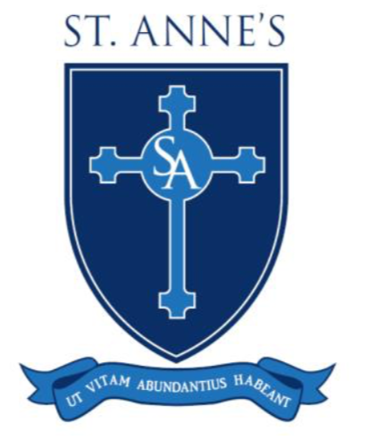

12th June 2019

Statement from the Trust Board of the Blessed Christopher Wharton Catholic Academy Trust

Dear parents,

We are writing to inform you of a decision that we have made, which we believe will strengthen our Catholic primary schools through collaboration, partnership working and sharing good practice. We are determined that all of our schools are beacons of Catholic excellence where all of our children can thrive and grow spiritually and academically.

As many of you will be aware, Mrs Katy Cox has been the Executive Headteacher at St. Anne’s and has done a fantastic job in helping the school move forward after a very difficult period. She will be leaving us in July after a very successful time with us and we thank her for all she has done for St. Anne’s. Therefore, to strengthen our collaboration, we have agreed that from September, we will appoint Mr John Devlin as the Executive Headteacher for all three of our schools, ensuring that standards are the very highest and that our Catholic community can become more united and thrive. He has lived and worked in Keighley throughout all of his career and knows our communities well. We are confident that he has the skills needed to take all of our schools on the next steps of their journey.

There will also be a Head of School in each school; Mr Andrew Arnold at St Joseph’s, Mr Paul Booth at St Anne’s and Mrs Catherine Mitchell at Our Lady of Victories, all of whom have our full trust and support. All schools will be separate organisations, but we will have a shared vision that we can work together towards. The schools will be like siblings - unique but not unalike.

Closer working between all of our schools will benefit all of our pupils and strengthen our Catholic communities.

We trust that you will be supportive of our endeavours and we are confident that you will all feel the benefits of this venture in the future.

Yours faithfully,

Mr Cameron Robson
Chair of the Blessed Christopher Wharton Catholic Academy Trust

