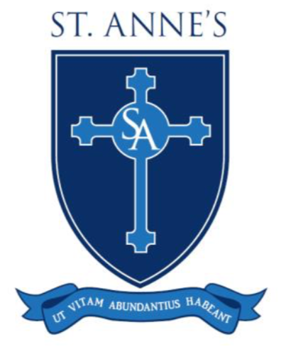
Keighley Catholic Schools
Holidays 2019 - 2020

Autumn Term

Re-open Tuesday 3rd September 2019

HALF TERM Close Friday 25th October 2019

Open Tuesday 5th November 2019

Close Thursday 28th November 2019

Open Tuesday 3rd December 2019

CHRISTMAS Close Friday 20th December 2019

Spring Term

Open Monday 6th January 2020

HALF TERM Close Friday 14th February 2020

Open Monday 24th February 2020

EASTER Close Friday 3rd April 2020

Summer Term

Open Monday 20th April 2020

MAY DAY Close Friday 8th May 2020

SPRING BANK Close Friday 22nd May 2020

Open Monday 1st June 2020

SUMMER Close Friday 17th July 2020

Inset Days
Monday 2nd September 2019
Monday 4th November 2019
Friday. 29th November 2019
Monday 2nd December 2019
Monday 20th July 2020

No holidays will be authorised during term time.

