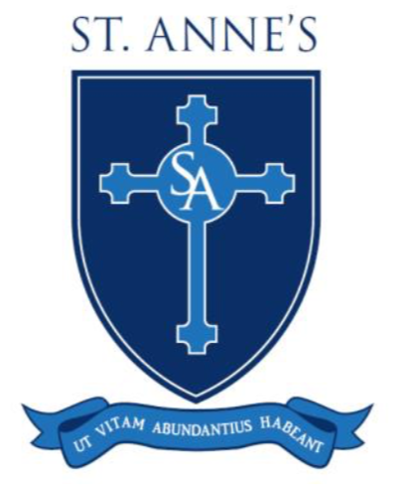

19th July 2019

Keighley Catholic Schools Holidays

Dear parents,

We are writing to inform you of a decision that we have made, which we believe will strengthen our Catholic partnership in Keighley. We have decided to coordinate our holidays exactly in order to make it easier for parents who have children at more than one school. As a result, there is a slight change in next academic year’s holidays. We are writing now in order to give everyone plenty of notice.

January 6th 2020 will no longer be an INSET day and the children will be in school. However, November 29th 2019 will become an INSET day and so the children will be at home on that day.

The new holiday lists will be on our websites and apps.

Wishing everyone a wonderful summer holiday and we look forward to seeing everyone in September.

Yours sincerely,

Mr J M Devlin Mr M Hings

